# JS Applications Exam Preparation – Meme Lounge

You are assigned to implement a **Web application** (SPA) using JavaScript. The application should dynamically display content, based on user interaction and support user profiles and CRUD operations, using a REST service.

## Overview

**Implement** a front-end app (SPA) for viewing and managing **memes**. The application allows visitors to browse through the memes catalog. Users may **register** with a **username, email**, **password** and **gender**, which allows them to **create** their own posts. Post authors can also **edit** or **delete** their own publications at any time.

## Technical Details

You are provided with the following resources:

* **Project scaffold**: A **package.json** file, containing a list of common dependencies. You may change the included libraries to your preference. The sections **devDependencies** and **scripts** of the file are used by the automated testing suite, altering them may result in incorrect test operation.

To **initialize** the project, execute the command npm install via the command-line terminal.

* **HTML** **and CSS files**: All views (pages) of the application, including **sample** user-generated **content**, are included in the file **index.html**, which links to CSS and other static files. **Each view is in a separate section** of the file, which can be identified by a **unique class name or id** attribute. Your application may use any preferred method (such as a **templating library** or manual visibility settings) to display only the selected view and to **navigate** between views upon user interaction.
* **Local** **REST service**: A special server, which contains **sample data** and supports **user registration** and **CRUD operations** via REST requests is included with the project. Each section of this document (where applicable) includes details about the necessary **REST endpoints**, to which **requests** must be sent, and the **shape** of the expected **request body**.

For **more information** on how to use the included server, see **Appendix A: Using the Local REST Service** at the end of this document.

* **Automated tests**: A complete test suite is included, which can be used to test the correctness of your solution. **Your work will be assessed, based on these tests.**

For **more information** on how to run the tests, see **Appendix B: Running the Test Suite** at the end of this document.

**Note:** When creating HTML Elements and displaying them on the page, **adhere as close as possible to the provided HTML** samples. Changing the structure of the document may **prevent the tests** from running correctly, which will **adversely affect your assessment grade**. You may **add attributes** (such as **class** and **dataset**) to any HTML Element, as well as **change "href"** attributes on links and add/change the **method** and **action** attributes of HTML Forms, to facilitate the correct operation of a routing library or another method of abstraction. You may also add hidden elements to help you implement certain parts of the application requirements.

## Application Requirements

### Navigation Bar (5 pts)

Implement a **NavBar** for the app: navigation links should correctly change the current screen (view).

Navigation links should correctly change the current page (view). **Guests** (un-authenticated visitors) can see the links to the **Home Page,** **All Memes** page, as well as the links to the **Login** and **Register** pages. The logged-in user navbar should contain the links to **All Memes** page, the **Create** **Meme** page, **Welcome, { user’s email address }**, **My Profile** page and a link for the **Logout** action.

**User** navigation example:

**Screenshot_5.png**

**Guest** navigation example:



### Home Screen (5 pts)

The initial screen should display the navigation, register, login and the initial image + footer.

**Note**: This page should be only visible for guest users. Logged-in users should be redirected to the **All Memes** page.

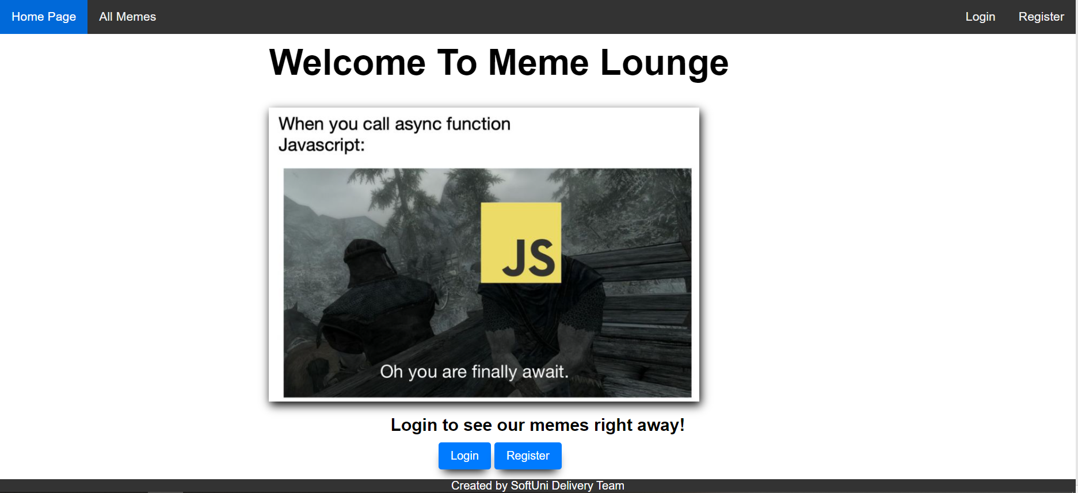

### Login User (5 pts)

The **included REST service** comes with the following **premade** user accounts, which you may use for development:

{ "email": "peter@abv.bg", "password": "123456" }

{ "email": "mary@abv.bg", "password": "123456" }

The **Login** page contains a form for existing user authentication. By providing an **email and password** the app should login a user in the system if there are no empty fields.

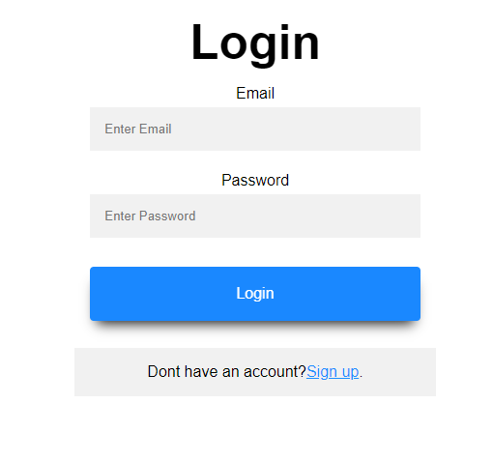

Send the following **request** to perform registration:

Method: POST

URL: /users/login

Required **headers** are described in the documentation. The service expects a body with the following shape:

{

email,

password

}

Upon success, the **REST service** will return the newly created object with an automatically generated **\_id** and a property **accessToken**, which contains the **session token** for the user **–** you need to store this information using **sessionStorage** or **localStorage,** in order to be able to perform authenticated requests.

If the login was successful, **redirect** the user to the **All** **Memes** page. If there is an error, or the **validations** don’t pass, display an appropriate error message, using a system dialog (window.alert).

### Register User (10 pts)

By given **username, email,** **password and gender (Male or Female)** the app should register a new user in the system. All fields are required – if any of them is empty, display an error.

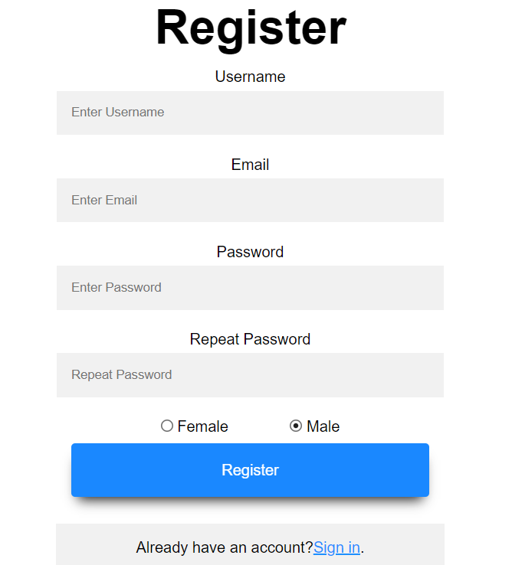

Send the following **request** to perform registration:

Method: POST

URL: /users/register

Required **headers** are described in the documentation. The service expects a body with the following shape:

{

username,

email,

password,

gender

}

Upon success, the **REST service** will return the newly created object with an automatically generated **\_id** and a property **accessToken**, which contains the **session token** for the user **–** you need to store this information using **sessionStorage** or **localStorage,** in order to be able to perform authenticated requests.

If the registration was successful, **redirect** the user to the **All** **Memes** page. If there is an error, or the **validations** don’t pass, display an appropriate error message, using a system dialog (window.alert).

### Logout (5 pts)

The logout action is available to logged-in users. Send the following **request** to perform logout:

Method: GET

URL: /users/logout

Required **headers** are described in the documentation. Upon success, the **REST service** will return an **empty response**. Clear any session information you’ve stored in browser storage.

If the logout was successful, **redirect** the user to the **Home** page.

### Create Meme Screen (15 pts)

The Create page is available to logged-in users. It contains a form for creating new meme. Check if all the fields are filled before you send the request.

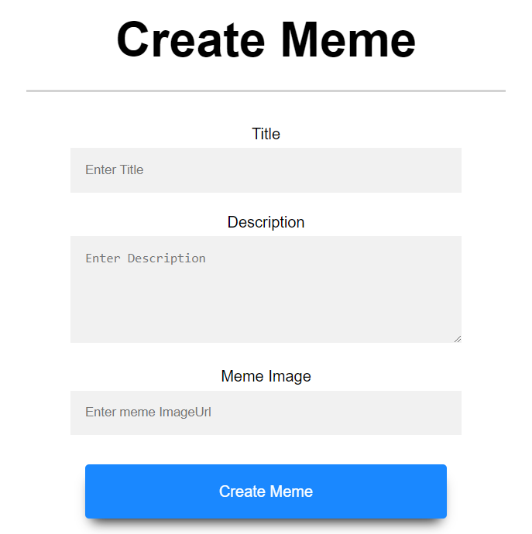

To create a meme, send the following **request**:

Method: POST

URL: /data/memes

Required **headers** are described in the documentation. The service expects a body with the following shape:

{

title,

description,

imageUrl

}

Required **headers** are described in the documentation. The service will return the newly created record. Upon success, **redirect** the user to the **All** **Memes** page.

### All Memes (10 pts)

This page displays a list of all memes in the system. Clicking on the details button in the cards leads to the details page for the selected meme. This page should be visible to guests and logged-in users.

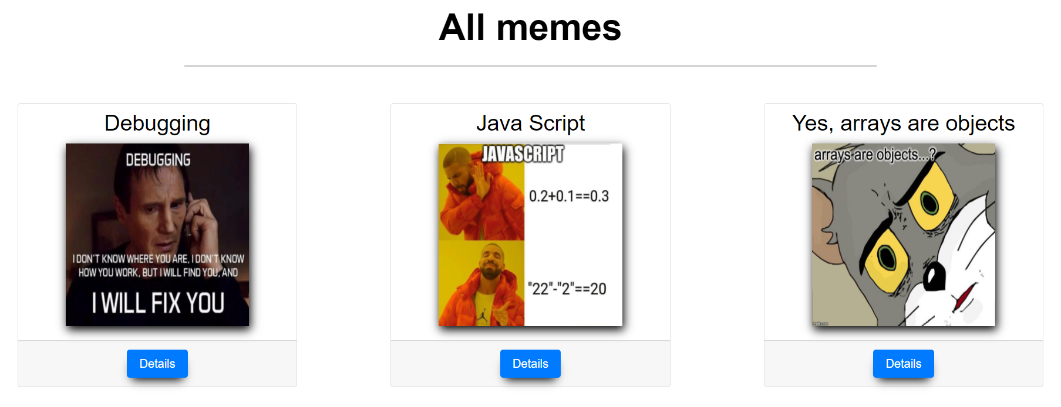

If there are nomemes, the following view should be displayed:

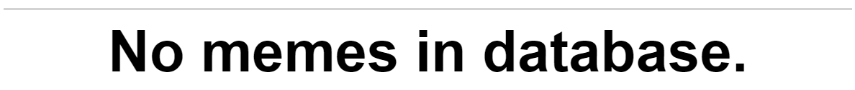

Send the following **request** to read the list of ads:

Method: GET

URL: /data/memes?sortBy=\_createdOn%20desc

Required **headers** are described in the documentation. The service will return an array of memes.

### Meme Details (10 pts)

All users should be able to **view details** aboutmemes. Clicking the **Details** link in of a **meme card** should **display** the **Details** page. If the currently **logged-in user is the creator** of the meme, the **Edit** and **Delete** buttonsshould be displayed, otherwise they should not be available.

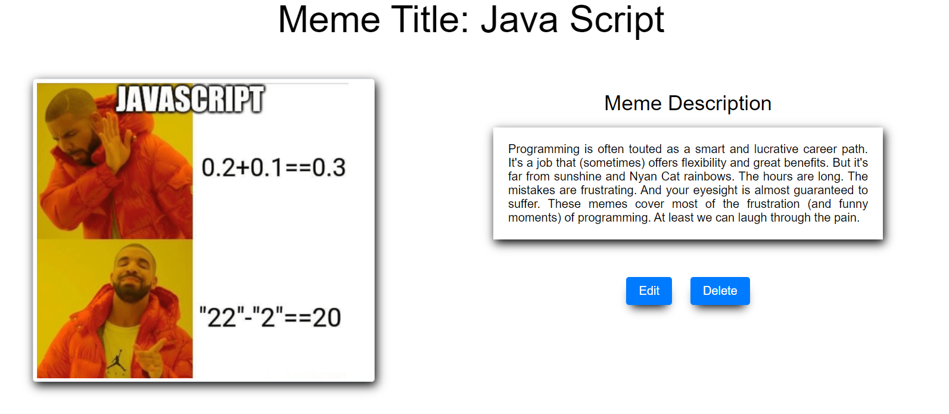

Send the following **request** to read a single meme:

Method: GET

URL: /data/memes/*:id*

Where ***:id*** is the **id** of the desired meme. Required **headers** are described in the documentation. The service will return a single object.

### Edit Meme Screen (15 pts)

The Edit page is available to logged-in users and it allows authors to **edit** their **own** memes. Clicking the **Edit** link of a particular meme on the **Details** page should display the **Edit** page, with all fields filled with the data for the meme. It contains a form with input fields for all relevant properties. Check if all the fields are filled before you send the request.

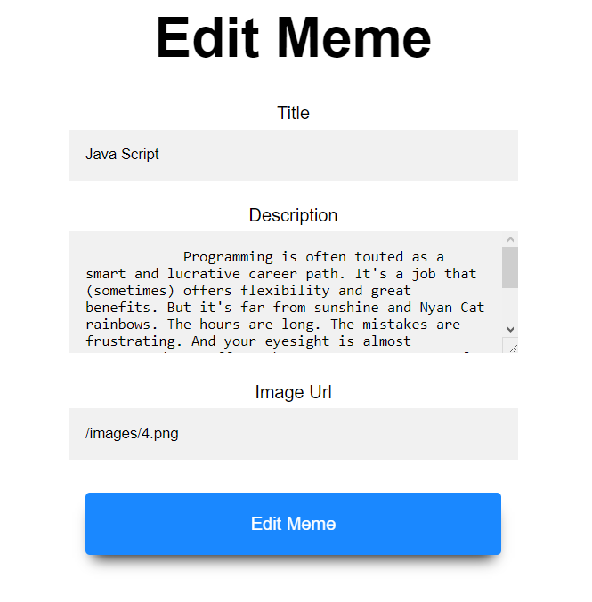

To edit a meme, send the following **request**:

Method: PUT

URL: /data/memes/*:id*

Where ***:id*** is the **id** of the desired meme.

The service expects a body with the following shape:

{

title,

description,

imageUrl

}

Required **headers** are described in the documentation. The service will return the modified record. Note that **PUT** requests **do not** merge properties and will instead **replace** the entire record. Upon success, **redirect** the user to the **Details** page for the current meme.

### Delete Meme (10 pts)

The delete action is available to **logged-in users**, for memes they have created. When the author clicks on the Delete action on any of their meme, a confirmation dialog should be displayed, and upon confirming this dialog, the meme should be **deleted** from the system.

To delete a meme, send the following **request**:

Method: DELETE

URL: /data/memes/*:id*

Where ***:id*** is the **id** of the desired meme. Required **headers** are described in the documentation. The service will return an object, containing the deletion time. Upon success, **redirect** the user to the **All Memes** page.

### User Profile (10 pts)

Each **logged-in** **user** should be able to view his own profile by clicking [**My Profile**]. Username, Email and My memes count should be filled with the data for the current user. Note that the Gender of the user determines which picture is displayed as their avatar.

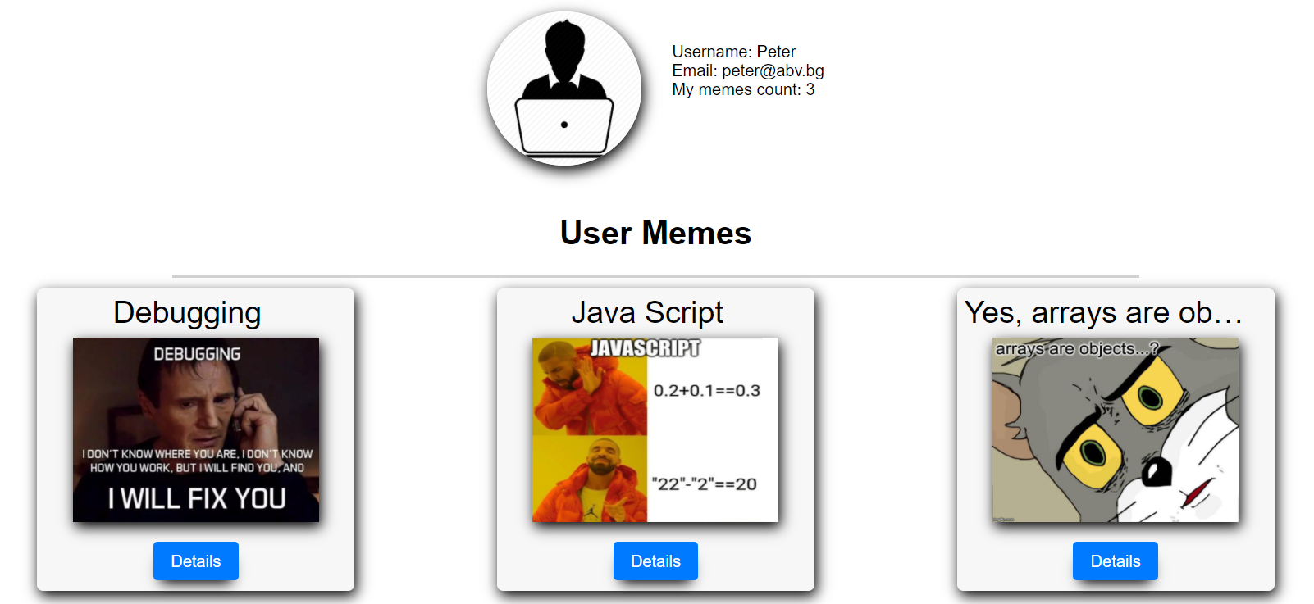

If there are nomemes, the following view should be displayed:

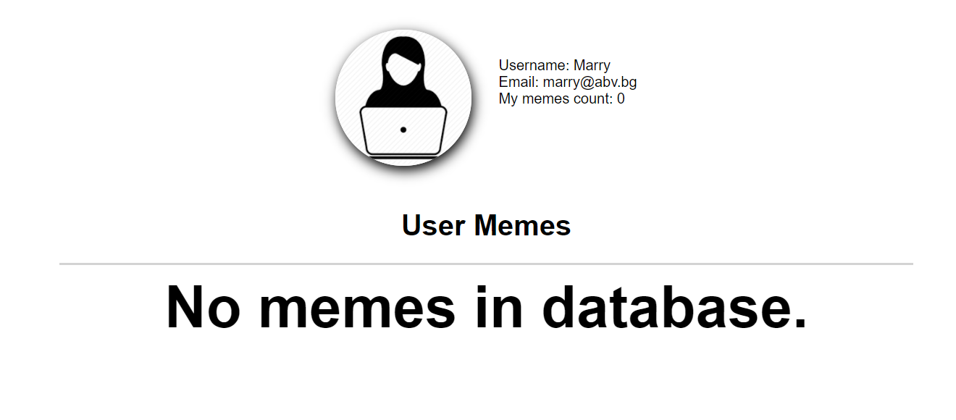

Send the following **request** to read the list of ads:

Method: GET

URL: /data/memes?where=\_ownerId%3D%22*{userId}*%22&sortBy=\_createdOn%20desc

Where ***{userId}*** is the id of the currently logged-in user.

Required **headers** are described in the documentation. The service will return an array of memes.

### BONUS: Notifications (5 pts)

In case of **error caused by the user’s actions**, the application should display an **error notification message**, which disappears after 3 seconds. There is a **styled section** with **id "notifications"** in the provided HTML file.

Errors may include **validation errors** or error **messages returned** by the REST service, such as incorrect user credentials, on the following pages: **Register**, **Login**, **Create** and **Edit**.

